Proposed Paiv MIS Language:

1. NOTE: If a product has two lengths (see screen shot below). The Product is sequenced across the life of the contract. Example:
   1. Months 1-2 are for quantity 25 * $59 / user for a grand total of $2,950.
   2. Months 3 - 10 are for quantity 45 for a total of $26,550
2. This step-up pricing is incorporated into the quarterly invoicing cadence. In the example below the invoice sequence would look as follows when properly processed (Amount in the table below is inclusive of discounts).

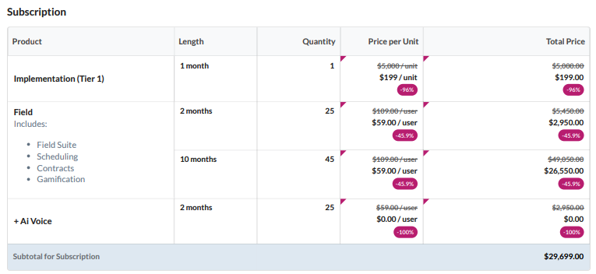

| **Invoice Number** | **Quantity** | **Product** | **Period** | **Amount** |
| --- | --- | --- | --- | --- |
| 1 | 1 | Implementation | Month 1 | $199.00 |
| 1 | 1 | AI Voice | Month 1 - Month 2 | $0.00 |
| 1 | 25 | Field | Month 1 - Month 2 | $2,950.00 |
| 1 | 45 | Field | Month 3 | $2,655.00 |
| 2 | 45 | Field | Month 4 - Month 6 | $7,965.00 |
| 3 | 45 | Field | Month 7 - Month 9 | $7,965.00 |
| 4 | 45 | Field | Month 10 - Month 12 | $7,965.00 |